Data Networks Project 0

Part 1: Running client and server code on same machine.

After making the different directories and compiling the server.c and client.c files, I ran the following commands to verify that socket was working as intended. The below code is a general overview of the steps taken with the navigating of directories left out.

1. Mkdir program
2. Mkdir Project 0
3. Scp client.c warn0000@gpel9.cs.ou.edu:/home/warn0000/program
4. Gcc client.c
5. Gcc server.c
6. ./a.out
7. ./a.out 127.0.0.1

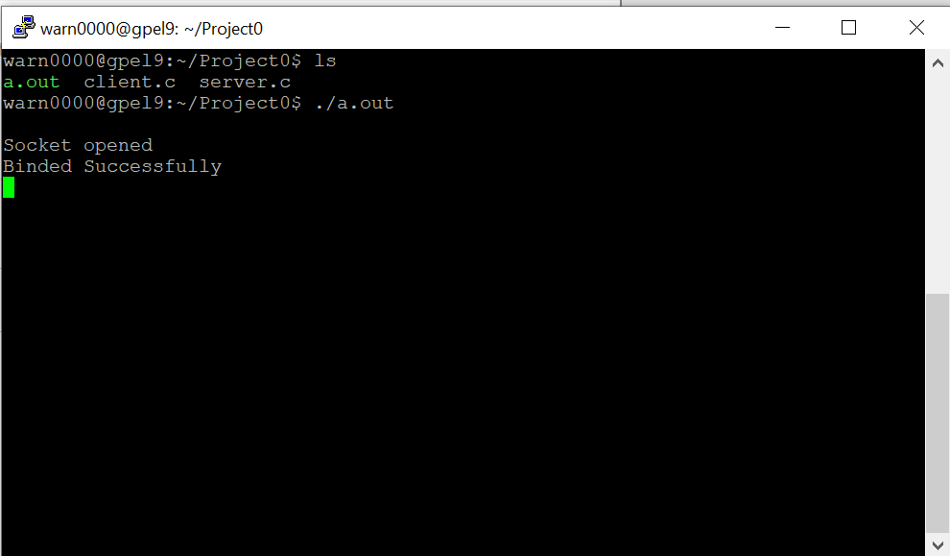

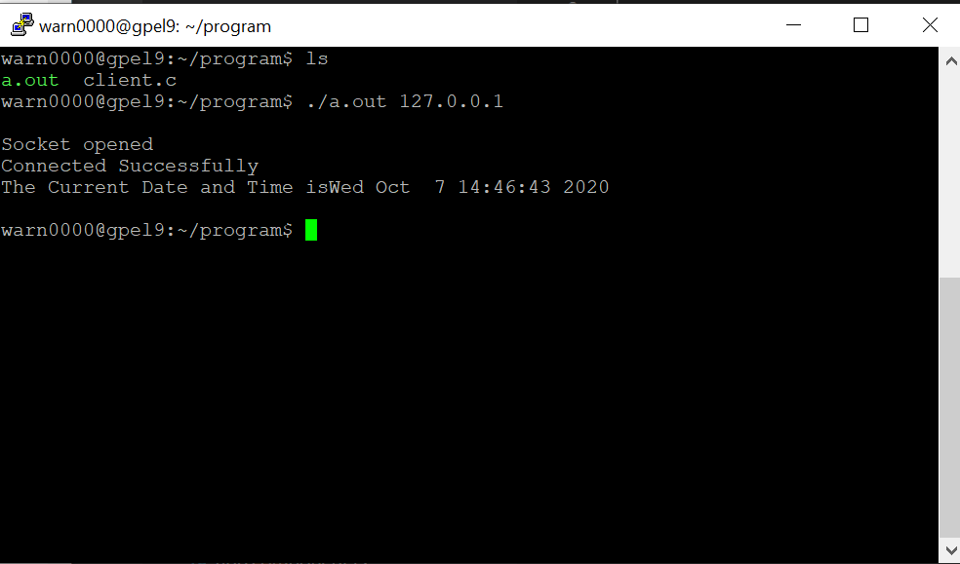

Part 2: Running the client and server code on different machines

The following steps are essentially the same as before with the only exception being that it is run on two different machines

1. Mkdir program
2. Mkdir Project 0
3. Scp server.c [warn0000@gpel9.cs.ou.edu:/home/warn0000/program](mailto:warn0000@gpel9.cs.ou.edu:/home/warn0000/program)
4. Scp client.c [warn0000@gpel8.cs.ou.edu:/home/warn0000/program](mailto:warn0000@gpel8.cs.ou.edu:/home/warn0000/program)
5. Hostname -i
6. Gcc client.c
7. Gcc server.c
8. ./a.out
9. ./a.out 127.0.1.1

